**Q1. Write an SQL query to retrieve a list of unique cities from the student table.**

**Query –**

SELECT DISTINCT city

FROM student;

**OUTPUT**

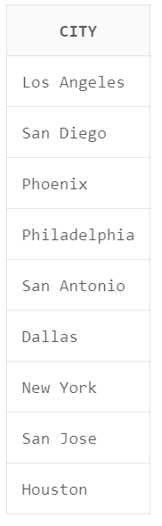

**Q2. Write an SQL query to retrieve all columns from the student table where the city is 'New York' and the phone number is '123-456-7890'.**

**Query-**

SELECT * FROM student WHERE city = 'New York' AND phone_number = '123-456-7890';

**OUTPUT**

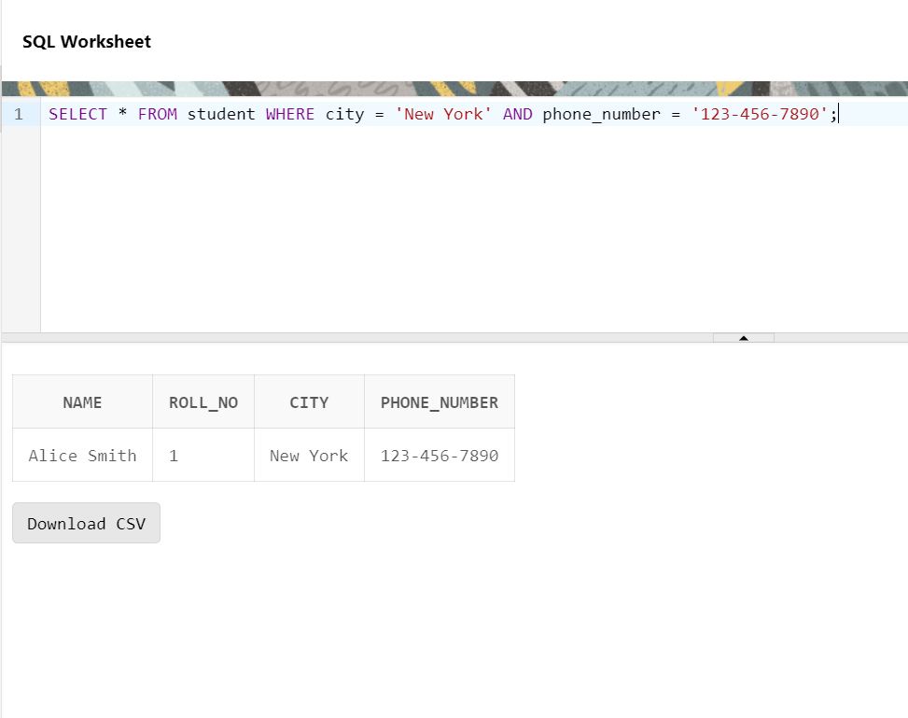

**Q2. Write an SQL query to retrieve all columns from the student table where either the city is 'New York' or the phone number is '123-456-7890'.**

**Query-**

SELECT * FROM student WHERE city = 'New York' OR phone_number = '123-456-7890';

**OUTPUT**

